CS 340 README Template

About the Project/Project Title
This project is a Python CRUD module that connects to the Austin Animal Center (AAC) MongoDB database. The module allows users to create, read, update, and delete animal records stored in the database. It was developed using Python and PyMongo to provide a reusable way for applications to interact with MongoDB. This module will be used as the database component for the Grazioso Salvare dashboard application.

Motivation
The purpose of this project is to create a reusable database interface that simplifies interactions with the Austin Animal Center database. By placing all database operations into a single Python module, the code becomes easier to maintain, reuse, and expand. This project serves as the foundation for future dashboard development that will help Grazioso Salvare identify dogs suitable for rescue training.

Getting Started
To get started, the Austin Animal Center dataset was imported into MongoDB using the mongoimport tool. A database named aac and a collection named animals were created. A user account named aacuser was also created with read and write permissions to provide secure database access.
After the database was configured, a Python CRUD module was developed using the PyMongo library. The module contains methods for creating, reading, updating, and deleting records from the database. The functionality was tested using a separate Jupyter Notebook file.

Installation
- MongoDB
  - Stores animal shelter records.
  - Chosen since it is flexible NoSQL database
- PyMongo
  - Allows Python to communicate with MongoDB.
  - Used to create and read records from the database
  - Install with: pip install pymongo
- Python
  - Used to create the CRUD module.
- JupyterLab
  - Used to test the Python code.

Usage
The CRUD module allows users to insert, retrieve, update, and delete records from the Austin Animal Center database.

Code Example
from CRUD_Python_Module import AnimalShelter

shelter = AnimalShelter()

new_animal = {
"animal_id": "TEST001",
"name": "Buddy",
"animal_type": "Dog",
"breed": "Labrador Retriever"
}

result = shelter.create(new_animal)
print(“Create Result:”, result)

results = shelter.read({"animal_id": "TEST001"})
print(results)

updated = shelter.update(
{"animal_id": "TEST001"},
{"name": "Max"}
)

print("Records Updated:", updated)

deleted = shelter.delete({"animal_id": "TEST001"})

print("Records Deleted:", deleted)

Screenshots
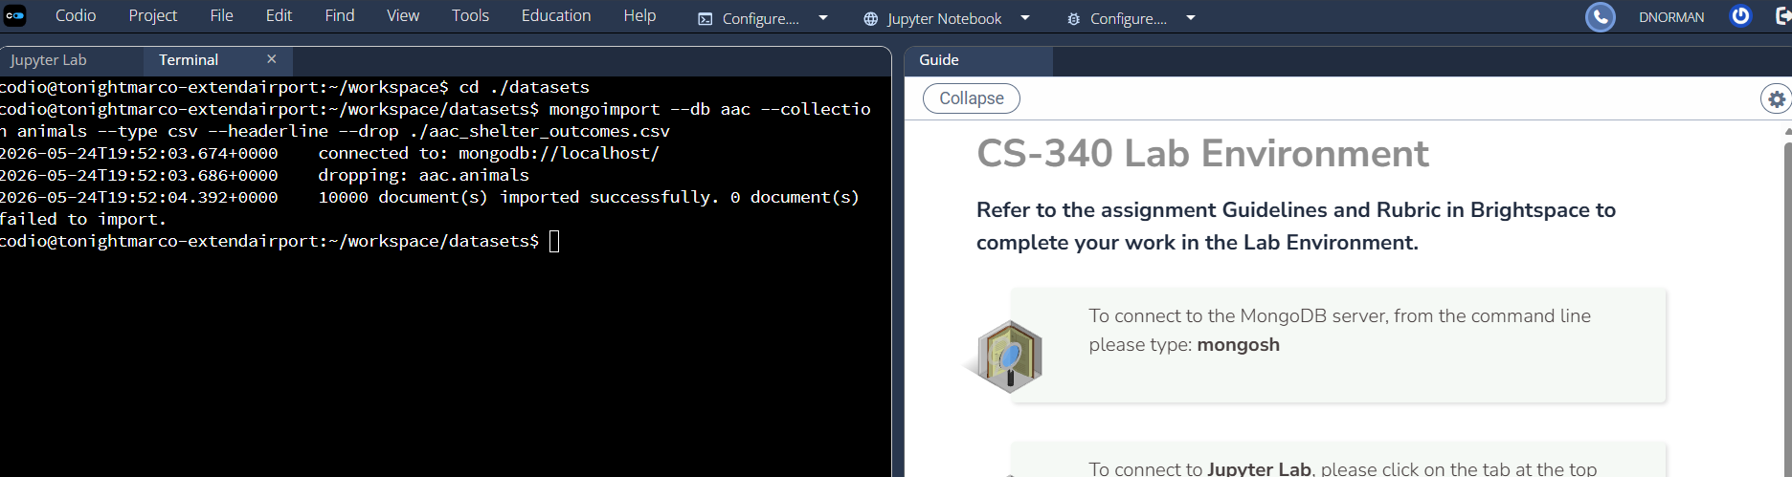
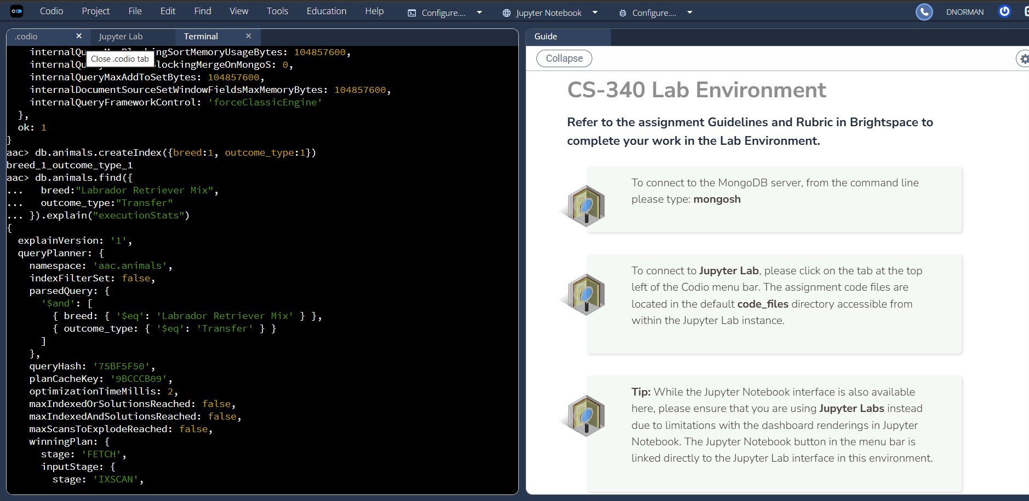
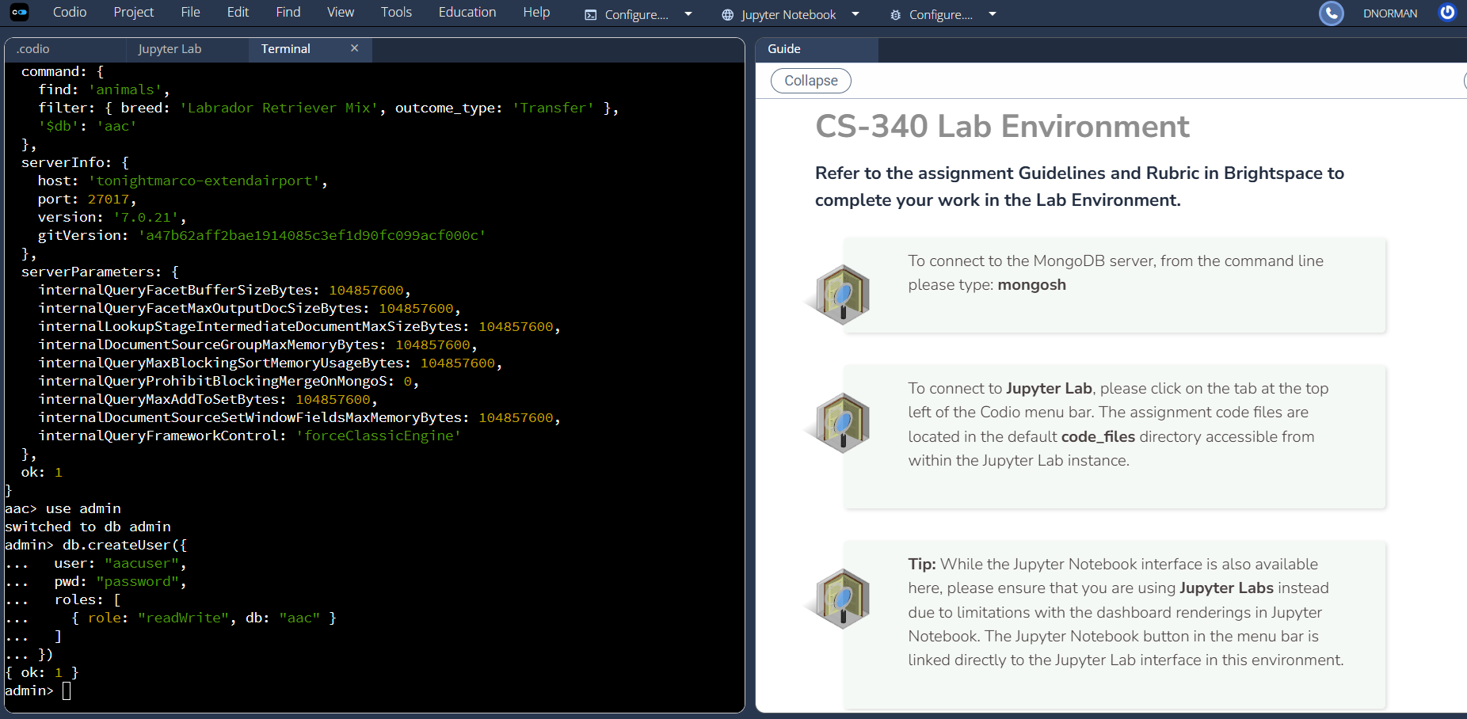
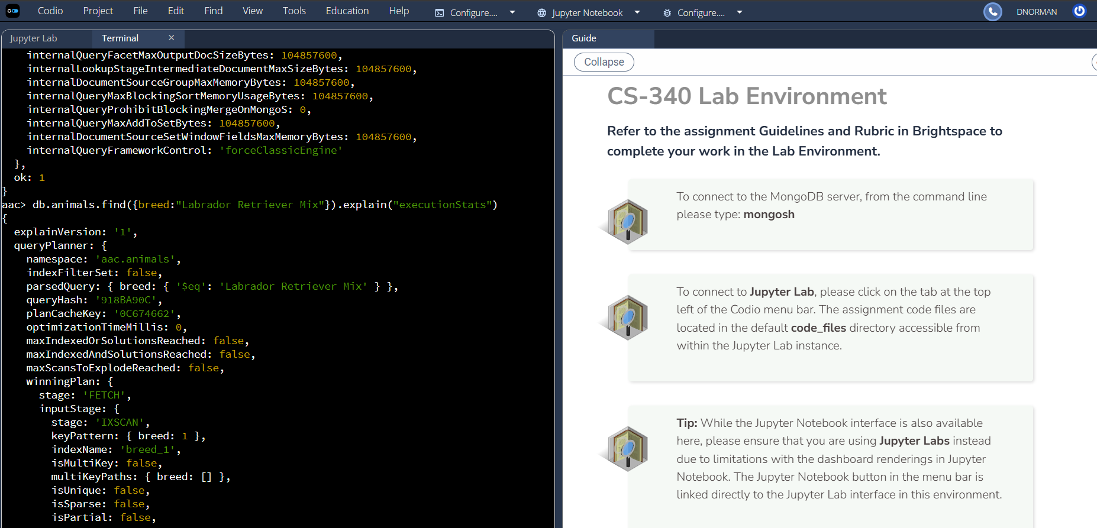
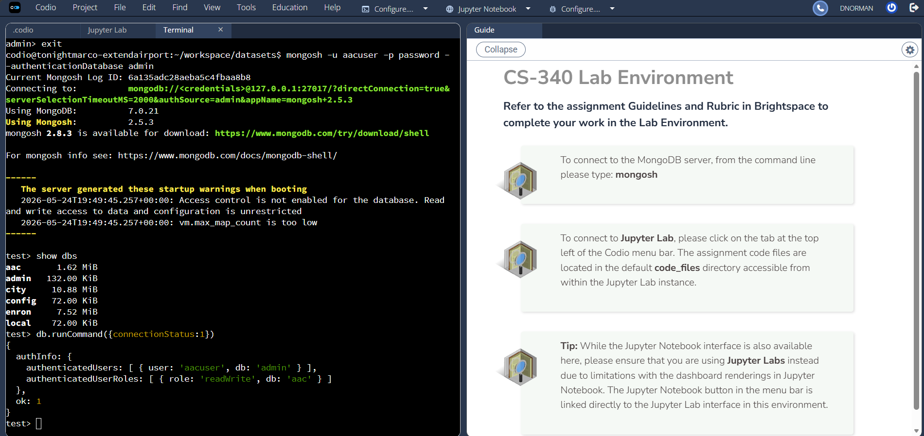
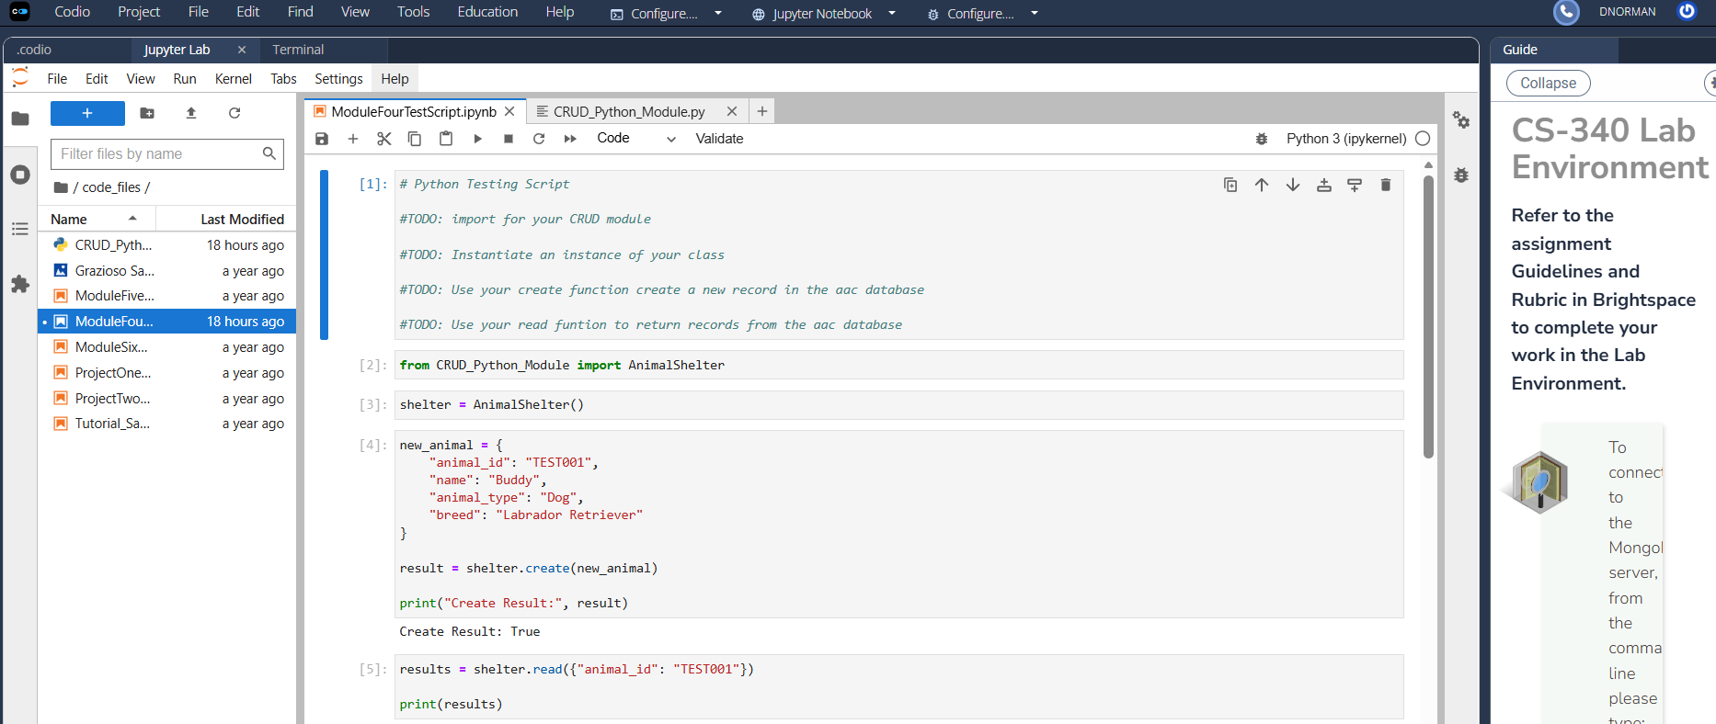

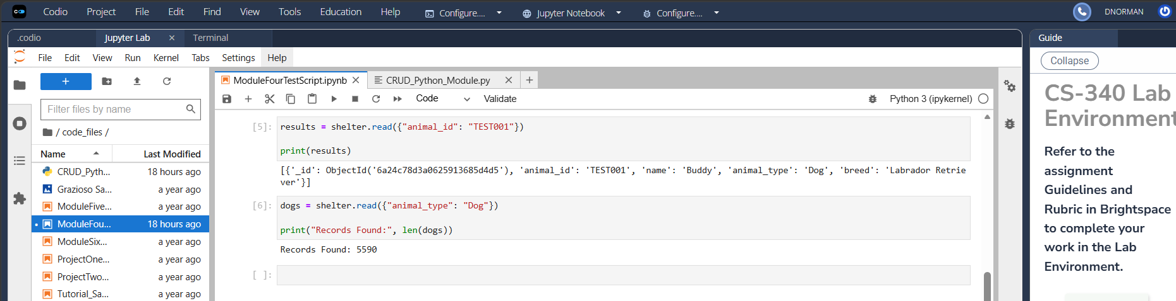
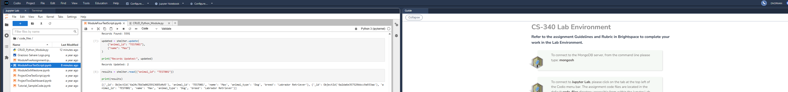
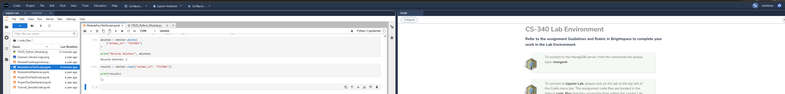

Contact
Your name: Daniel Norman

